Requirements Specification
Geo Learn
12/12/19
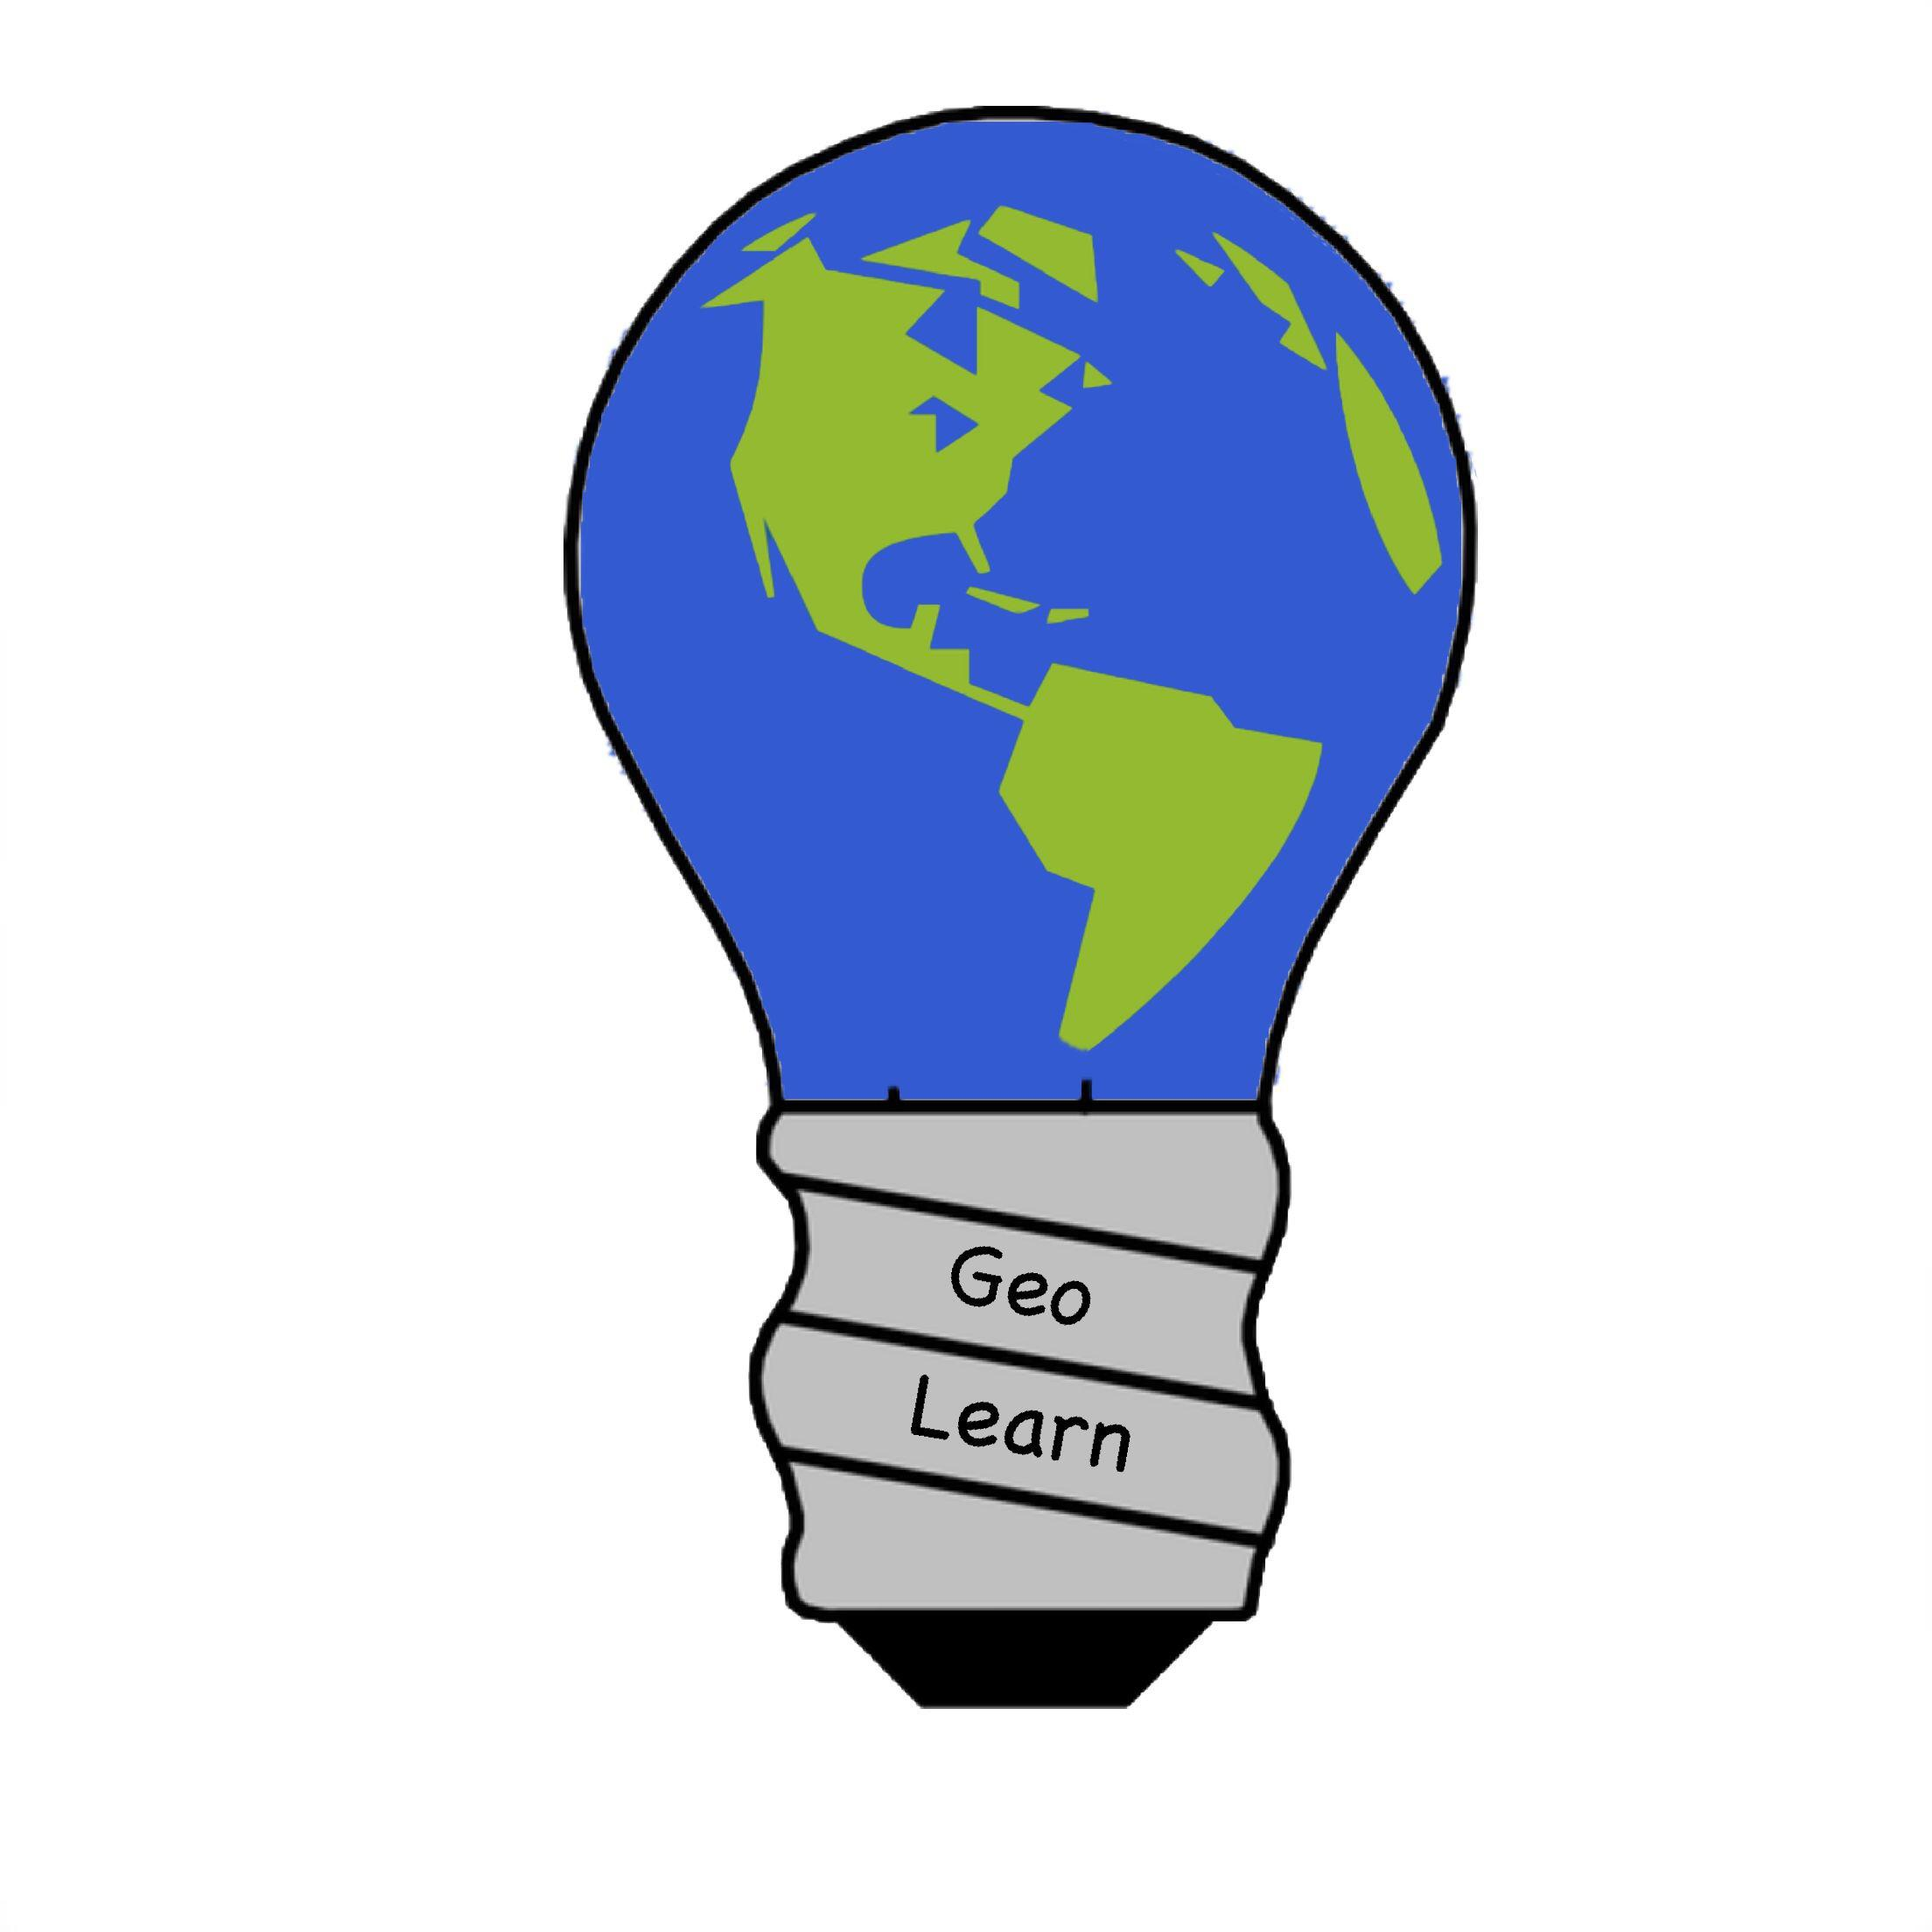
Mentor: Fabio Santos
Sponser: Dr. Chris Doughty
Team members: Samuel Prasse (lead), Kaitlyn Grubb,
Tyler Pehringer, Joshus Tenakhongva

Accepted as baseline requirements for the project:

Sponsor For the team

_________________________ Date: _______ _________________________ Date: _______

_________________________ Date: _______
Table of Contents

- INTRODUCTION……………………………………………………………………..pg2
- PROBLEM STATEMENT………………………………………………………..…..pg3
- SOLUTION VISION……………………………………………………………..…...pg4
- PROJECT REQUIREMENTS……………………………………………………....pg6
  - Domain………………………………………………………………………...pg6
  - Functional…………………………………………………………………......pg8
  - Performance…………………………………………………...…………....pg11
  - Environmental……………………………………………………………….pg14
- POTENTIAL RISKS………………………………………………………………...pg16
- PROJECT PLAN……………………………………………………………………pg18
- CONCLUSION……………………………………………………………….……..pg20

Introduction
One of the biggest problems today is climate change. There is a great divide between people who believe that it exists or not. All of this information stems from when people learn about changes in the environment. There are some technologies out there that help people try to understand, such as GreenMete that measures the environmental impact that a single person has on the environment as well as what people do as a whole to the environment.

In addition, education in the United States is the cornerstone of our society. In the Fall of 2019, about 56.6 million students will attend elementary, middle, and high schools in this country. Through the years, students learn valuable skills and lessons that shape them into the intelligent and well equipped citizens that have the opportunity to change the world. In the United States, students progress through a grade level system in which their knowledge is built upon the previous years information. The public school system will enroll 51.4 million students this year and with only 3.2 millions teachers, their jobs have never been more critical.

Our sponsor is Dr. Chris Doughty, a professor and researcher of Ecoinformatics for over 15 years. Our team is working closely with Dr. Doughty as well as his team of Graduate researchers which includes Andrew Abraham. Dr. Doughty has generated interest in the education program through his wife who is a teacher at a local school in Flagstaff, as well as his two children who are enrolled in the public school system. He has been researching and working on projects to better help people understand the effects of climate change on our world. This is one of the most prevalent topics in our society today with the effects mostly unknown by the general public.

Because of this problem, Dr. Doughty has employed our team to create an educational tool for use in classrooms in the United States and all over the world. This tool is being designed for use by teachers and students alike. It will allow teachers to create geo-specific slideshow presentations containing information such as: land use change, precipitation, biodiversity, and fire. The Google Earth Engine is a tool that allows us to capture satellite data over a period of time, create a time lapse of the changes, and implement the exported file to our slides. These short video clips will be just one of additions to our slides that will help students develop a better understanding of the changing world around them. Our team will be using data from a prior project Dr. Doughty has worked on known as Ecolocation. This database houses thousands of data points and pictures of herbivores, carnivores, and even humans, based on where they were located when they were living. By utilizing this data, we will create a visual representation of what animals lived close to the area requested by the teacher. This project will be implemented as a web application so it can be accessed from anywhere by anyone with a Google login. The students will also have access to this application from in the classroom or from home. The tools that we are building to create our presentations will be implemented into the web application so students can gather time lapse, or animal data on any location in the world. This tool will provide students and teachers an incredible new way to view the world around them, all the while being easy to understand and comprehend.

Problem Statement

Now, when it comes to teaching this information to younger students, it can be a hassle. For teachers, they can run into some of these different issues. One is that teachers might not know how to simplify environmental information down enough for kids of any age to understand. This information is very complicated to get together, but this information is useful and important to try to understand and teachers generally would like to have their students understand what they teach as optimally as possible. Teachers would also want to make sure that the data on the environment was correct. In the age of the internet, good and bad information is just as prominent as ever. Students need to be able to learn the best information on the environment as possible so that they can be better at determining what would be the best ways to improve it later on in life. Lastly, teachers might not have enough time to create these presentations or lectures having to do with the environment. The time it takes to make a slide for a small presentation with research can take hours to properly set up the information they are trying to teach to their students.
For students, this information can be quite hard to understand. There is so much information that comes into the public eye and not many people know how to really simplify it down for these students to understand. This mainly, however, stems from how old the student is. Not only that, but teachers need to find a way to make this type of information interesting for their students. It is hard to make sure that a presentation grips a students attention, but by doing so you help them retain what is being taught, possibly in the long term.

In summary issues include:
- Massive amounts of information lead to
  - Skills and technology needed to access information
  - Loss of time compiling data
  - Confusion and misinformation given to students
- Students often learn about information not directly related to their lives
- Teachers cannot convert data for different age groups in reasonable time

Currently there are no applications that can help with these problems all at once. There is no application that automatically generates presentations based on environmental science. We need an application that can automatically generate slide presentation for teachers, that will convey environmental information in a simple to understand way. We need an application that can help teachers find accurate information about all areas in the world, including environmental information in their local area. However, this is an application that our group is tasked to create.

Envisioned Solution

In order to allow teachers to access data in a more reasonable manner we propose to design a web application that will allow users to input location and gather information based on this location. For teaching purposes there will be slideshow generation on multiple topics that are based on location. To accompany this the web application will also have interactive activity pages that include the same functionality and tools that generate the presentation. This allows kids to not only relate the information to their area but also locations they have visited or are interested in.

In order to accomplish this our base web application will include:

- A landing page to inform and welcome users
- Generation of slideshows based on location and subject
- Interactive accompaniment to the slideshows

A Landing Page to Inform and Welcome Users: This page on the website is for welcoming the user to the website and giving an idea of what Geo Learn has to offer. A few of the slide show subjects will be displayed here as well as a small blurb about our project.

Generation of Slideshows Based on Location and Subject: This is the main solution to our problem. Teachers cannot easily access important and relevant data to teach students. Slides will be generated using templates created by our sponsors and tested at the College of Education at Northern Arizona University. This allows teachers to get relevant data without coding knowledge or searching for random facts on the internet.
As pictured in figure 1, this will work by passing data between different web applications. First a user would select a location and subject. Next the needed information will be gathered from one of our databases based on the subject and location. Currently we have two main databases we are using to gather information. First, we have the Google Earth Engine. This will give us climate change information for the user’s location. Second, we are using a database a previous capstone made that contains shapefiles (the location of animals) and information about animals like height, weight, and extinction predictions. This is where we will get information for our biodiversity slide set.
This data will then be transformed into plotting points, a time-lapse, or pictures. This will then be passed over to a Google Slide. This is where the template made by our sponsors will be filled with the transformed data. The slideshow is then saved to the users Google Drive account.

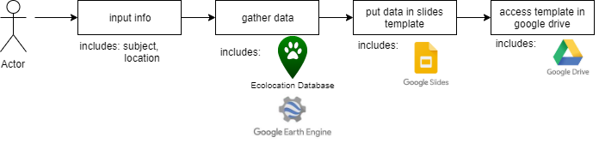
Figure 1: A flow diagram of how making a slide show will use many APIs to generate slides.

Interactive Accompaniment to the Slideshows: This will have the same data gathering as the slides creation except instead of displaying the information on a slide the information will be shown on a webpage.

This solution will not only give teachers access to more relevant data, but will also reduce the amount of time it takes them to compile lecture slides. This enables the teachers to focus more on teaching and less on compilation of the lesson. In addition interactive activities will help stimulate and relate the students more with lectures. Having the lectures based on location will encourage kids to care more about issues such as climate change because the issue seems more relevant to them.

Project Requirements

4.1 Domain
The following requirements are considered to be our most general requirements. Domain requirements are requirements that cover the overall needs of the software and do not cover functions and specific interactions.

- Generate slides automatically:
The idea of the application is to make sure that the application can take environmental information from different databases and format that information onto a Google Slide.
The slides will be generated so that they will fit a specific format approved and tested by teachers so the information will be easy for the teacher to teach this information to their students. We will format the slides so that they will have a simplified format to place this information. We will make the slides so that they will display small bits of information as well as pictures of animals and land changes. We will have the Google Slides API with a set format to place this information.
In order to test this, we will take sample information from the capstone Ecolocations application, Animaps. We will generate animal information from one animal given to us from the app and on a slide, this includes text info and a picture. We will also take sample information about land change from the Google Earth Engine API and place this information onto a Google Slide with the same format. Once those tests are successful, we can then move onto making sure that we can grab information on the same topic, but of different categories within that topic.

- Slides need to be generated based on location, subject, and age:
This means that the slides must have relevant information based on what city they live in. The software will need to extract information that is relevant to the many options the user can select. This information will be gathered from environmental databases. We will be using Google Earth Engine to gather this information for climate change information, as well as a past capstone project called Animaps to gain animal information based on the location of the user.
We will use the technologies used in order to get the correct location and information based on that location for the user. The slides themselves would be have formatted information based on the user’s location, such as land change and biodiversity. This is so that it will be easier for the students to retain the information given to them in the slides. Since the slides will have local information for them to learn about, they will understand better why it is important to try to improve and preserve our environment.
Our product is about using location data to create a slideshow. The areas that our software can draw upon isn’t limited to the United States and Europe. Our software should be capable of drawing data about anywhere on the planet.
To test this, we will simply use Flagstaff as a base location for biodiversity and land change. We will do the same test as the one we use to test automated slide creation, since the two go hand in hand for the minimum viable product (MVP). The result will lead to hopefully gathering different environmental science information and data types based around the Flagstaff area. This includes but is not limited to: fire burn maps, rainfall numbers, and resource usage graphs.

- The presentations must have interactive slides:
This means that all presentations must have small activities for the students benefit. This will include simple mix and match activities for the students of younger age groups. We are also going to gain videos of other short lectures based around the specific topic that is specified by the teachers that are using our application. This is to ensure that students will be able to retain the information given to them based on any age group.
We can create scripts that will each create different sections of the slide show. There could be a script that creates the information part of the slideshow, and there would be a script that creates the interactive part of the slideshow. When creating a slideshow, the user can decide what types of slideshow they want to use and what types of interactive activities they want to include.
For example for a younger audience learning about biodiversity, using the ecolocation database, we can search for images of animals using the scientific name or the common name and create a matching game. Since this mix and match activity will likely be aimed at younger audiences, the selection of animals may have to be reduced but can be broadened for older audiences.

- Slides must be saved to users’ Google Drive:
Since we are using Google Oauth automatic authorization for user authentication, development, and data gathering, we must use Google accounts for our application. We are also using the Google Slides API in order to create the automatically generated presentations which is already linked to Google accounts. Google accounts allows another well developed and familiar environment for teachers to easily navigate.
In order to test this, we will create sample slides based on the format given to us by our sponsor. We will use the Google Slides API to create the format as well as hard coding this information into the slides to ensure that they can be saved to the users Google Drive account. We will need to be sure that the Google Slides API gives us authorization to place new slides into the drive by means of using Python code to generate the slides. Once this test is complete, we will then make sure that the format we use will be rid of the hard coded example and modify it so that it can take in the information given to us from the two databases we are tasked to us for the MVP.

4.2 Functional
The following requirements are considered to be our most important functional requirements. Functional requirements are requirements that the user can interact with and fall under the domain level categories.

- Generate slides automatically:
- A user must click the generate button and then wait for the slide show to be created

- Slides data needs to be gathered based on location, subject, and age:
- User need to put in information such as
  - Age range - Allows slides to contain more games, less information, and more relatable terminology for kids versus more graphs and content for high schoolers.
  - Subject - Allows our project to be used by a wider range of teachers and teach more diverse subjects.
  - Location - Allows slide data to be gathered by location. For example, shows squirrels to students in Flagstaff and snakes to students in Phoenix in order to be more relatable and impactful.

- The presentations must have interactive slides:
- A user must be able to interact with at least one of the slides.

- Slides must be saved to users’ Google Drive:
- Google email accounts must be given by the user to generate a slide show.
- A user can access the slideshow in their Google Drive.
- A user must be able to perform basic slideshow operations like present, edit, and delete.

Note that our functional requirements seem very minimal. This is because our project is supposed to take a lot of work off of the user and develop slides in the background.

Stretch Goals
- Being able to grab information on different animals such as birds and fish
  - Currently, the database that we’re using to draw animal information, Ecolocation, only has information on mammals. In the future, we could create databases that include other types of animals like birds and fish that our slideshows could draw upon and provide more information to students. These different animal categories could be different slideshow categories under the biodiversity umbrella or be incorporated into the biodiversity slides themselves. If we include both of these options, that just leaves more options for teachers to choose from.
- Making quizzes an interactive slide
  - Using a script to create quizzes inside the slides, we can also create slides that are the quizzes for students. Google slides has a variety of tools that allow for different types of interactivity with slides such as animations, slide transitions, and slide skipping. We could create a quiz template that would create questions from a question database or question template that students could engage with during a lecture. Once students answer, the teacher would click on the answer that the students agreed on, and the slideshow would show if the students got the right answer, and if not, what the right answer is. Google Slides, and by extension, by the API, offer a lot of tools to work with to create in-slide quizzes and other activities for students to participate in.

- Making slides into different languages
  - Using another Google product, Google Translate, we should be able to translate our slides into other languages for educators around the world to use. While Google Translate isn’t perfect, it is a very robust translation system that has improved with time. Since our product relies on another Google property already, we have determined that it is safe to rely on another, even more well supported piece of software. Using Google Translate to translate our slides and educational material to other languages means that as our product ages so will Google Translate. As time has gone on, it has become more and robust, meaning that our product will have this automatically integrated.
- User ratings for the presentations
  - For our presentation slideshow templates, users can leave comments and ratings on each template so our team can get feedback on each template and make adequate changes to the templates.
- User ratings for the quizzes
  - Users will be able to leave comments and ratings for the different quiz templates, so our team or future teams can know what needs improving and create new or alter existing quiz formats to suit the needs of educators.
- Giving users the ability to upload their own slide template and quiz formats
  - Once we have integrated a system for logins and login security we will include a social aspect to our software that will allow users to upload their own formats for slides that they have created and want others to see.
- User ability to download other users slides and quizzes
  - Once users have uploaded slideshow and quiz formats, other users can then download their formats and potentially leave ratings and comments on these formats. The User uploaded content can be a big inspiration for the development team to know what works and what doesn’t, so we can appropriately improve the base templates and formats.

4.3 Performance
- Slide Generation
Using slideshow templates provided by our client, our software will create educational slides for educators for many ages to use. This will be done using the Google Slideshow creation tools provided by Google.
The information inserted into the slideshows will be based on data drawn from AniMap and Google Earth Engine. Thanks to our client and the Ecolocation capstone team, we have the tools and the information to draw from to create these slides.
We have access to the AniMap database that has information on more than 7,000 animals and their habitat locations.

- Save slides to Google Drive
As we developed our product, we have determined that accessibility was a key performance requirement of the application. This will be accomplished through validating student and teacher logins through Google authentication. Users must register a Google email account before use of the application. This is one of the requirements the team deemed necessary, especially for teachers, for ease of use with our web application. Because the goal of the application is to be educational, we wanted access to the site to be as quick and easy as possible.
We will use official methods, provided by Google, to authenticate the Google account that the software will send the slideshow to. The overall process of creating an account and logging into the website will take under five minutes for the average user. Then, each subsequent time a user would like to access the site, they will be able to do so in the time it takes them to enter the URL into their browser.

- Gather data based on location, subject, and age
The location information is passed to our generation script which has a parameter for location coordinates.

Land Use change
In our Land Use Change slides, these coordinates will be used in the code to geolocate the school, area, or landmark that the teacher has selected, and request a time lapse, graph, and picture of the general area. The graph will contain population growth data in a range of 100 kilometers from the center of the coordinates. In testing, video exportation from the execution of the script in the Earth Engine API to the time the rendered video was available in the users Google Drive was around 2 minutes.
The video we tested was a time lapse of the growth of Flagstaff over the past twenty years. It was two frames per second making the length around thirty seconds. This was tested multiple times and the results were similar each time with the longest allotted time around one minute. With video creation being the most time consuming aspect of using the Earth Engine API, these tests proved to the team that we will be able to create a full scale presentation in under ten minutes. These presentations will grow as we develop our application but for the minimum viable product, our presentations will contain the aforementioned time lapse videos, graphs, and pictures as well as relevant information relating to the area selected by the teacher at the beginning of the process.

AniMap
In our Biodiversity slides, the coordinates will be used to draw information about animals around the area the user input. The coordinates will be based on latitude and longitude, allowing for a global search of animal data. Our biodiversity information gathering module will also search within a range of 100 kilometers like the Land Use Change module.
If an animal’s habitat is this area, information about this animal will be returned to be put into the slideshow. Information such as the animal’s mass, level of endangerment, the animal’s taxonomy and other information is available to be put into the slideshow. Whatever information that may not be useful in a slideshow format could be useful for searching for more data on the animal on the internet. This is how we will provide up-to-date and high quality images of the animals.

- Slideshow interactivity
Our client has also requested that we create interactive slides based on the information gathered. We plan on doing this by eventually separating our slideshow creation software into 3 smaller pieces. One that will create the lecture slides, one that will create the interactive slides, and one that will merge the two together.
The reason we’ve chosen to do it this way is to make sure that both sections are as clean and focused as they possibly can. This way, we can mix and match different interactive templates with different subject templates. Doing this would decrease the total number of slideshow templates we would need to create and also increasing the ease of expanding the amount of subjects and interactive templates our project can use. Both of these slides would draw from the same information gathered from the Google Earth Engine and the AniMap database.

- Ease of Use
Our primary goal is to provide educators easy access to large amounts of data about the environment, so they may use it to educate others. To do this, we need to ensure that our software user interface and user experience is as robust as our slide creation. Here, users will have access to the tools that the team has created to develop time lapse data, graphical data, and photographical data from Google for any location they are interested in. This process will take a smaller amount of time for the user because instead of the data being inserted into our slideshow skeleton, the data is being presented in real time to the user within the web application. This process will be completed in under a minute due to the small amount of processes being done. This time window is critical for our project because we want the application to be easy to use and efficient enough to where the user wants to keep accessing information about different areas they are interested in.

4.4 Environmental
- Language Constraints
When developing code for the Google Earth Engine, we are constrained to writing our code in either JavaScript or Python. Google has developed an API for the Earth Engine in Python which can be written from the command line. The team has decided to develop our product using a Linux distribution. This allows us to take advantage of the command line tools that are present in unix based machines. Because the Earth Engine has the Python version of the API, we will be developing our code for the API’s using the PyCharm integrated development environment.

- Proper Version Control and Documentation for Future Developers
Our Github repository will be well organized and code well documented to create an environment that we can pass on to whomever will be taking over after we leave the University, as well as ensuring that our sponsor will understand what each piece of code is doing and so his team team can contribute as well if they deem it necessary.

- Send the completed slideshows to the users’ Google Drive account
Our sponsor has requested that the slideshow presentations that we create must be exported to the users Google Drive after completion. This allows the user to download the presentation as a PowerPoint and edit the slides to their satisfaction. This means we must include a Google login system that authenticates the emails and will access the users Drive to save the slideshow presentations.

- Utilize the AniMap database and integrate its functionality
The Ecolocation tool which was created as a past Capstone project that Dr. Doughty and his team has worked on will be implemented into the web application as well. The Ecolocation team was tasked with creating a mobile application which stores data of animals living or extinct. We are planning on implementing this application as one of the pages on our website, as well as accessing their teams SQL database for use in our slideshow presentations. This will be done by using shape files that we will upload to our database and access using the scripts we will write that will include geo-specific animal information in the slides. Because their team used a SQL database, we will be writing our code to access this information in SQL.

- Use and create more environmental databases for other wildlife subjects
Our sponsor and his team and our Capstone team have been working together efficiently by relying on each other for our specific skill sets. They are allowing us to take creative direction on how the web application will be implemented with the language we are programming in, and the process of how our information will be generated into a slideshow presentation. They are assisting us by providing us with shape files which contain flora and fauna data, ideas to include in future iterations such as bird and other types of animal data, and sample code from the Earth Engine of datasets they would like included by the final implementation of the product. Dr. Doughty has also reached out to several faculty in the Education department at Northern Arizona University to set up times where both teams can take a version of our web application into classrooms in Flagstaff to demonstrate and gather test data on our application.

5. Potential Risks
- Google Earth Engine Become Unavailable
Likelihood: Very Low
Google is one of the largest companies in the world with a record of discarding projects in their infancy, but Google Earth Engine is very likely to be a long term project. It’s been around for nearly a decade and has many projects utilizing it as its backbone. It’s unlikely that Google will stop supporting it or that Google will go out of business.
Severity: High
Google Earth Engine is the main component of our project. If it becomes unavailable to us, we will need another piece of mapping software like ArcGIS. ArcGIS is capable of performing many of the same functions, but at a much higher cost.

- Amazon Web Servers Become Unavailable
Likelihood: Very Low
Amazon is an enormous company. Many websites including ones that professors in the NAU Computer Science department use, utilize Amazon’s web service to host their websites. The likelihood of Amazon cutting off support or Amazon going out of business is very low.
Severity: High
Should this happen, Amazon is not the only web service around that we can use for hosting. Our second choice is Oracle HTTP Server service.

- Political Backlash Against Teaching Kids About The Environment
Likelihood: Low
Our client brought to our attention that there may be backlash from parents who don’t want their children being educated about climate change in this way.
Severity: High
Should this happen, we would need to change our slideshow templates and retest how they work as educational material with teachers, which would cost a lot of time.

- UI (User Interface) needs improvement
Likelihood: High
We are not professional user interface designers. It is unlikely that either our team or our clients will create a UI that is as intuitive as we would like.
Severity: Medium
It may take a few iterations to get the UI to a level that non-tech savvy users feel comfortable with it. This would require more testing with folks who aren’t tech savvy, but it would not destroy the usage of our product. Testing would be easier since we would be testing for usability and not for usefulness in the classroom. While finding users who we want to test the functionality will be easier than testing the classroom viability of our slides, it will still take time to test, record our findings, and implement them.

- Database Security
Likelihood: Medium
We gained access to the Ecolocation database because it was insecure. The way that Python integrates with the SQL API requires that we have our login credentials in the source code.
Severity: High
If someone gains access to the database, they would change anything or delete it. The login credentials are also on the Ecolocation Github, open for anyone to see. When we are creating our final release, we may have to create our own database from the Ecolocation database in order to ensure security and not let the files that contain the login on the Github.

- Animal database needs updating
Likelihood: High
The mammal animal kingdom isn’t changing radically a whole lot, so this information wouldn’t need updating a lot.
Severity: Medium
If this project continues for a while, there may be changes to which animals are extinct, how threatened they are, where their habitat is, etc. These need to be represented in the database.
We would need to either alter the ecolocation database, or we could create our own database with whatever improvements we think are needed. Altering the ecolocation database could make the Ecolocation project not work anymore, so it is more likely that we would pull the info from that database and create our own.

6. Project Plan
- Requirements and working on individual modules
November 8 - November 30
We are each working on individual parts of the project, the fetching of data from Google Earth Engine and Ecolocation, the creation of the slideshows from such information, and the website that will host the project. Once they are all completed, we are going to integrate our parts to form our tech demo and MVP.

- Prototype creation
December 8 - December 11
Once we have our pieces together, we are going to perform tests to ensure that our product works well and has as few bugs as possible. This is the product that we are going to present to our client to show our progress so his team can tell us what changes to implement in the future.

- Re-examine requirements with client after they can use the MVP
January 13 - January 27
Once we have a complete MVP, we will re-examine our requirements to make sure that what we have developed is exactly to our clients specifications and to see if they have decided on changes to our previous requirements.
Here we will also determine the exact implementation of future steps of the project such as the climate change and fire categories of the slideshow creation and how we will go about testing the slide templates and formats with educators and in the classroom.

- Work on the other slideshow categories (Climate Change & Fire)
January 13 - February 3
Our project so far includes only two slideshow categories: biodiversity and land use change. Our client wants 4 categories developed, the other two being climate change and fire. Climate change represents how the environment itself has changed in a broader sense. Fire represents how fire, both natural and artificial, has affected the land. These two will include timelapse data so users can visualize how they have changed over time.

- Testing GeoLearn with real teachers
January 13 - February 24
We will schedule appointments to work with teachers to see how well our slideshows work in an actual classroom setting. We will get feedback from teachers and integrate them into our slideshow format. This feedback is critical to the state of our project because it shows us how well the user interface was received by users, as well as the effectiveness of the site in the real world.

- Working on Age Specific Slides
February 3 - March 2
We will begin working with a variety of teachers who teach different age groups and get their feedback on how different age groups learn. Once we have this information, we can work on having GeoLearn use different slide templates and information based on the target age group. Younger age groups may require more interaction while older groups may be more receptive to more lecture-like slideshows.

- Quizzes and Slide Interactivity
March 2 - April 6
Some of our clients’ stretch goals include making quizzes based on the information we have drawn from Earth Engine and Ecolocation and implementing interactivity with the slides. Here, we will do research into good quiz structure and some testing with teachers to see if our quiz and slide interactivity aligns with what they would want to use in a classroom.

- Testing and polishing
March 2 - May 1
Here, we will have completed the main structure of the project and will have moved onto testing and polishing our product so the main structure is as robust as possible and our client is satisfied with the results. We want to ensure that GeoLearn is easy to expand since Chris Doughty, our client, has plans to expand the software to encompass more aspects of environmental education.

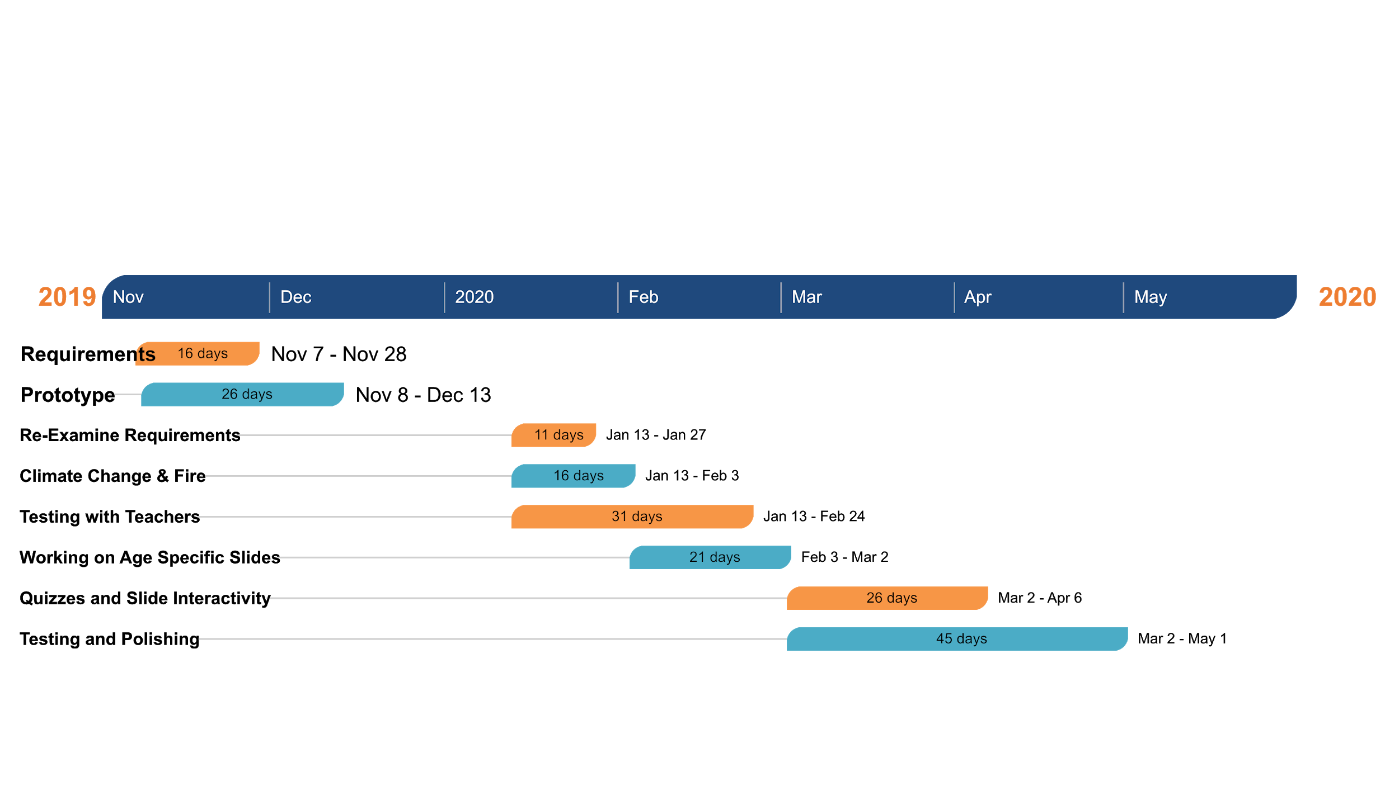

7. Conclusion
As the years go by, climate change has become a more pressing issue for us and an enormous danger to future generations. Much of the backlash against creating solutions for climate change has its roots in ignorance and misinformation. In order to prevent our children from sharing the same misguided ideals, we need to educate them using real world examples and information. Students may empathize more with the struggles that animals and the environment face if they were given more relatable information. Sadly, much of it is difficult to gather in a timely fashion. This is an enormous problem for school teachers who may not have the time or resources to gather this information. That is where our team comes in.
GeoLearn hopes to make this information accessible to educators who will use it to better educate future generations. Our product will draw upon environmental information databases and condense the information into slideshows that educators can use. The information will be based on location and category like biodiversity, land use change, climate change, and fire. This makes it easier for teachers to educate their students about how climate change affects the real world in ways that students can understand, empathize with, and internalize.
In this document, we talked about what exactly our client wants us to produce, how well he wants it produced, and how we plan to implement these features into the final product. We also discussed some potential risks that come with this project like the key technologies our product is relying on becoming unavailable to us, ensuring our database is accurate and secure, and political backlash against educating about climate change. We outlined a timeline for our project that shows when we plan to have certain features done, extending through the end of the project.
We have thoroughly planned how our development schedule is going to take place. The GeoLearn team is confident in the guidance of our mentor, our clients, and in the skill of the developers. We know exactly what we plan to do, how we are going to do it, and when we’re going to have it completed. We hope the contributions we are making to the environmental education field are significant. Once we can educate others, we hope that everyone can contribute to the protection, and sustainability of the place we call home.

